1. Just Recap about what we discussed so far.
2. PKI: Set of Algorithms, Rules, Protocols that allow you to build trust relationship b/w different entities (CA, Intermediate CA, and End-User).
3. Every Entity has a public key and based on those relationships we build trust to Public Keys.
4. 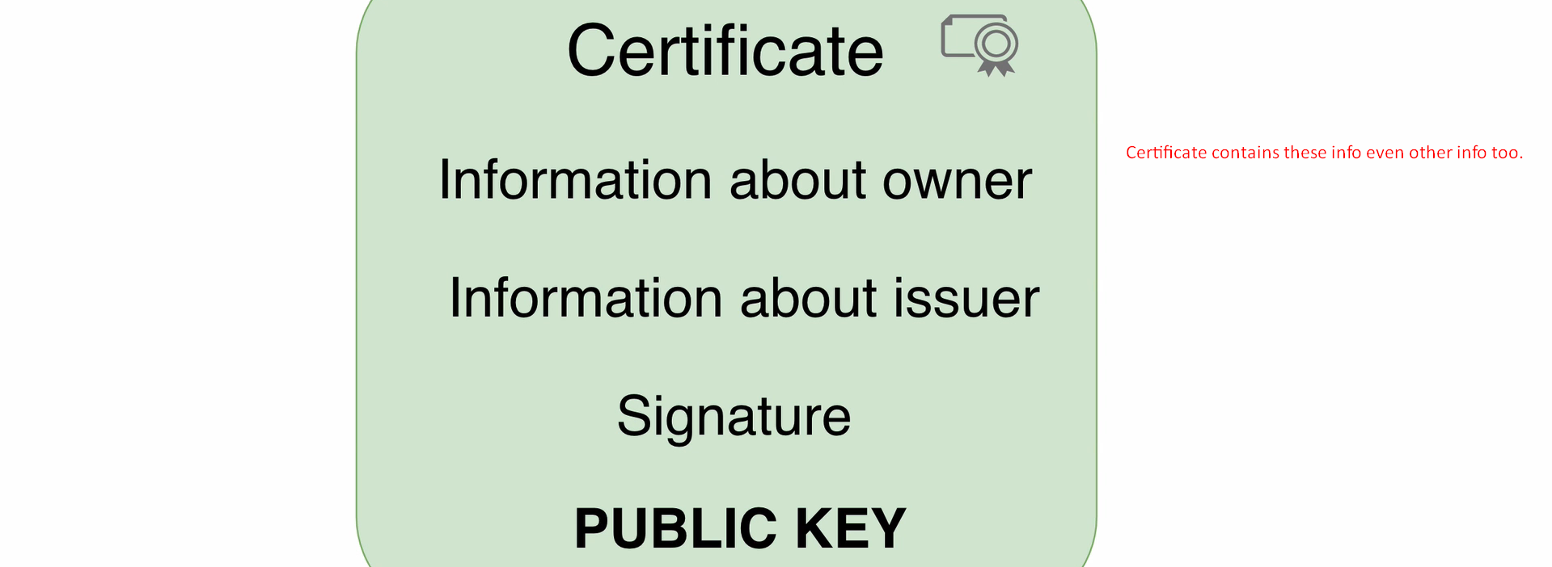
5. 